Do Simple Technical Indicators Survive Scrutiny? A Custom-Built Backtesting Study of RSI and MACD versus Buy-and-Hold
A Detailed Report
Drafted by
Ayush Mondal
August 2026

TABLE OF CONTENTS
Abstract 4
1. Background on the Trading Strategies 5
1.1 Relative Strength Index (RSI) 5
1.2 Moving Average Convergence Divergence (MACD) 5
1.3 Buy-and-Hold Benchmark 7
2. Methodology 8
2.1 System Architecture 8
2.2 Data Source and Instrument Universe 8
2.3 Signal-to-Trade Execution Model 8
2.4 Performance Measurement 9
2.5 Simplifying Assumptions and Sources of Marginal Error 9
Execution and portfolio mechanics 9
Data and instrument universe 10
Performance-metric calculation 11
Indicator construction and boundary conditions 12
3. Results and Experiments 14
3.1 Baseline Performance (Default Parameters, Full Sample) 14
3.1.1 S&P 500 Index (SPY) 14
3.1.2 Individual Stock -Tesla (TSLA) 19
3.2 Parameter Sensitivity 23
3.2.1 RSI Smoothing Span 23
3.2.2 RSI Entry / Exit Thresholds 34
3.2.3 RSI Maximum Holding Period 44
3.2.4 MACD Span Configuration 44
3.3 Temporal Robustness 44
3.3.1 Performance by Market Regime 44
3.3.2 Rolling-Window Stability 48
3.3.3 In-Sample vs. Out-of-Sample Split 49
3.4 Cross-Sectional Robustness (Sector and Volatility) 51
3.5 Geographic Robustness 51
3.6 Combined-Strategy Experiments 52
3.7 Stress Tests 54
3.7.1 Transaction Cost Sensitivity 54
3.8 Statistical Significance 60
3.9 Summary of Findings 61

(This table updates automatically with correct page numbers when the document is opened in Word. If it ever looks stale, right-click it and choose “Update Field.”)

Abstract
Technical indicators such as RSI and MACD are widely used to time entries and exits in equity markets, yet whether their apparent edge over simply buying and holding is genuine or an artifact of a favorable sample, a convenient parameter, or an untested assumption is rarely examined with real rigor. This report investigates that question using a complete backtesting framework built from scratch in Python - signal, portfolio, execution, and metrics modules that compute RSI and MACD trades under a one-day execution lag and score them (CAGR, Sharpe ratio, maximum drawdown, win rate) against a buy-and-hold benchmark - so that every assumption and parameter is author-written and inspectable rather than taken from an opaque library. The core contribution is not a single backtest but a program of scrutiny: the same strategies are re-run across parameter sweeps, historical regimes and an in-sample/out-of-sample split, combined-signal rules, transaction costs, and customized strategies. Reporting where this apparent edge survives or fails each test is intended to give an honest answer to whether simple technical indicators encode real, exploitable structure in price data or whether their reputation rests on results that do not generalize.
Keywords: technical analysis, RSI, MACD, backtesting, algorithmic trading, buy-and-hold, robustness testing, parameter sensitivity, market efficiency

1. Background on the Trading Strategies
Technical analysis rests on the premise that price history itself (not just fundamentals) carries information about what an asset will do next. Two of its most widely used tools show opposite versions of that premise: RSI bets that a price which has moved too far, too fast will revert; MACD bets that a price already trending will keep trending. This project sets both against each other and against a passive benchmark (Buy-and-Hold), each defined below with its formula and how it is implemented in the code.

1.1 Relative Strength Index (RSI)
The Relative Strength Index (Wilder, 1978) is a bounded momentum oscillator (0–100) which compares recent gains to recent losses and conventionally flags “oversold” (below 30) and “overbought” (above 70) conditions as points where a price move has stretched further than it can sustain:
RS = Average Gain ÷ Average Loss (over N periods)
RSI = 100 − [ 100 ÷ (1 + RS) ]
Project relation: RSI.py uses an exponentially weighted 19-span variant rather than Wilder's original smoothing (14-span). A buy requires RSI below 30 and price above its 200-day moving average, so dips are only bought inside a confirmed uptrend. The position closes on whichever comes first: RSI above 40, or a 10-day time stop.
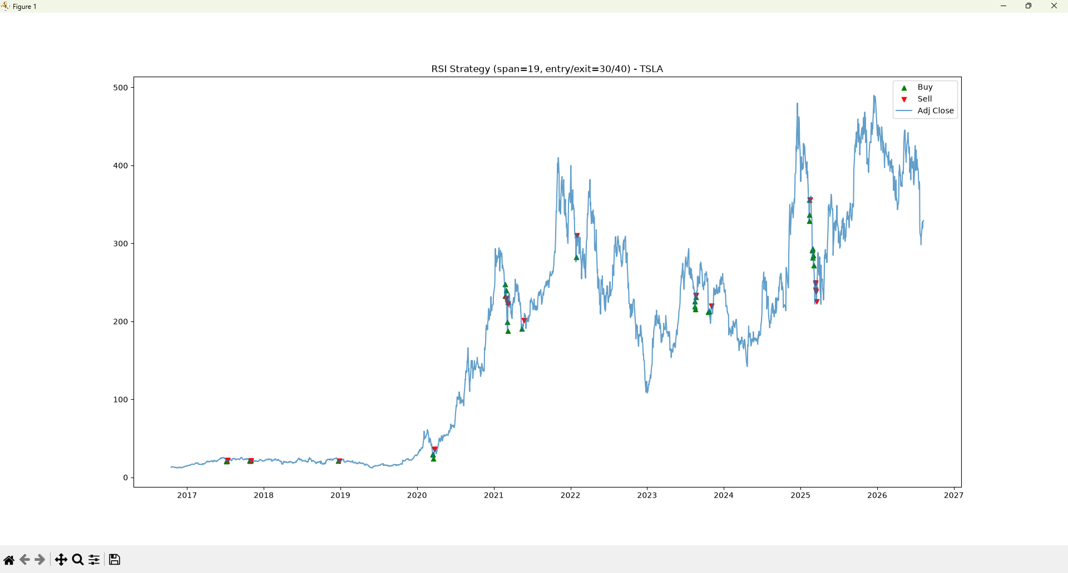
Figure -RSI strategy buy/sell signals plotted against price (TSLA, span=19, entry/exit=30/40)

1.2 Moving Average Convergence Divergence (MACD)
MACD (Appel, late 1970s) takes the opposite premise: rather than betting on reversion, it is built to detect and ride an existing trend in motion, using the difference between two exponential moving averages (EMAs) of price to predict whether short-term momentum is pulling ahead of or falling behind the longer-term trend:
EMA = Price·k + EMA(t−1)·(1−k), k = 2 ÷ (N+1)
MACD line = EMA₁₂ − EMA₂₆
Signal line = EMA₉ (Main MACD line)
Project relation: MAC.py uses the standard “12/26/9” configuration: EMA₁₂ minus EMA₂₆ gives the MACD line, smoothed further into a 9-period signal line. A buy fires on a bullish crossover (MACD crosses above signal), sell on the reverse, with execution delayed one day so trades confirm on a completed signal rather than one still forming.
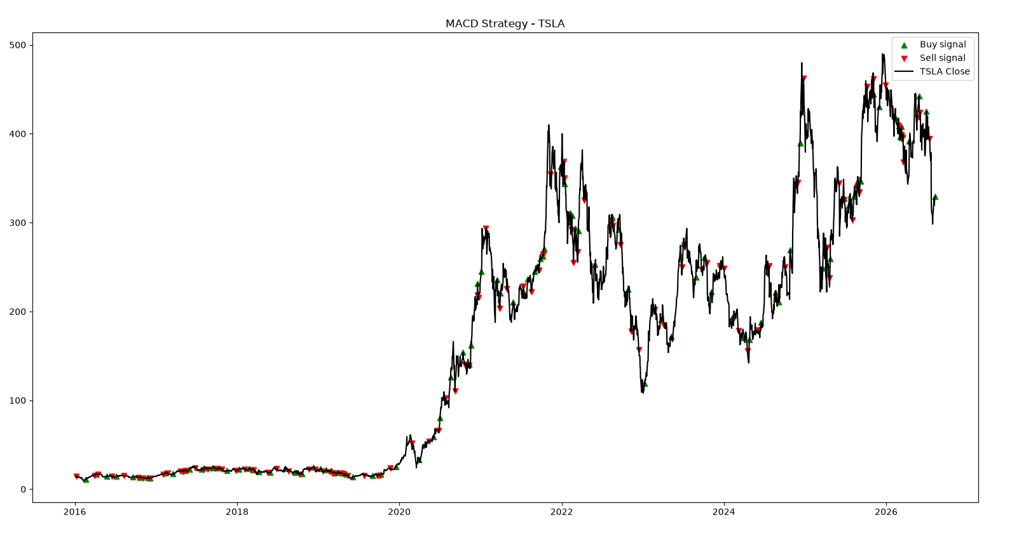
Figure -MACD strategy buy/sell signals plotted against price (TSLA)
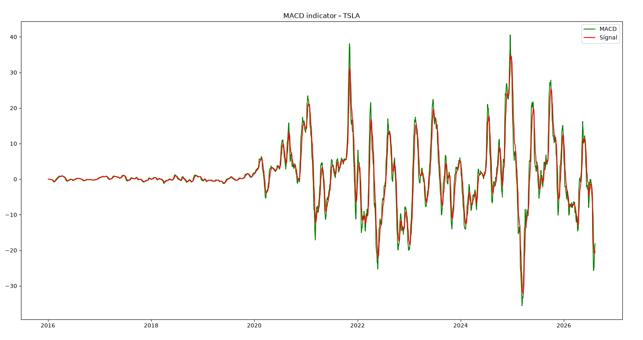
Figure -MACD line vs. signal line, the crossover indicator itself (TSLA)

1.3 Buy-and-Hold Benchmark
Buy-and-Hold is a fair referee between the two: capital is deployed once and left untouched until the end of the period, with no attempt to time entries or exits:
Total Return = (P_{end} − P_{start}) ÷ P_{start}
CAGR = (P_{end} ÷ P_{start})^{1/years} − 1
Project relation: Implemented in backtest_engine.py's buy_and_hold(), which buys at the first close and holds to the last, tracking a full daily equity curve. This gives RSI and MACD a frictionless benchmark they must beat on a risk-adjusted basis -not just on raw return.
Together, these three strategies -one betting on reversion, one betting on continuation, and one betting on nothing -form the comparative backbone this project uses to test whether technical timing adds value, all three run through a single, consistent backtesting pipeline so no strategy is given an implementation advantage over another.

2. Methodology

2.1 System Architecture
Rather than relying on a third-party backtesting library, the evaluation pipeline was built from four independent modules so that every step between “here is a price series” and “here is a Sharpe ratio” is author-written and inspectable. A signal layer (RSI.py, MAC.py) turns a downloaded price history into a label. A Portfolio class (portfolio.py) tracks cash, holdings, a full daily equity curve, and the list of completed trades, exposing only buy(), sell(), and update_equity() so that no code outside it can mutate account state directly. A BacktestEngine (backtest_engine.py) steps through the price series day by day, feeding each day's signal into the Portfolio and forcing it to mark to market every day regardless of whether a trade occurs. A metrics module (metrics.py) converts the resulting trade log into return, risk, and risk-adjusted statistics.

2.2 Data Source and Instrument Universe
All price history is pulled at run time from Yahoo Finance via the yfinance library, starting January 1, 2016 and running to the present - a roughly ten-year window that spans several distinct regimes (the pre-2020 bull market, the COVID-19 crash and V-shaped recovery, the 2022 rate-hike bear market, and the 2023–2025 rally). Here, I have used SPY exchange traded fund as a proxy for S&P 500. The pool of eligible individual stocks is the current S&P 500 constituent list, scraped live from Wikipedia by get_sp500_tickers().

2.3 Signal-to-Trade Execution Model
Once RSI or MACD has produced a BUY or SELL date, BacktestEngine.run() replays the price series day by day and enforces a strict state machine: a BUY is only acted on while the portfolio is in cash and a SELL is only acted on while a position is open, so the account is always either fully invested in one position or fully in cash - never both, never leveraged, never short. Every executed trade fill at that day's closing price, and Portfolio.update_equity() records the account's total value every single day, whether or not a trade happens, so the full equity path is available for later analysis. If a position is still open on the final day of downloaded data, it is force-closed at that day's close so that no unrealized position is left out of the final return figure. Buy-and-Hold is treated as the simplest possible case of the same model: one BUY on the first available day, held until a single forced SELL on the last.

2.4 Simplifying Assumptions and Sources of Marginal Error
Every backtest rest on simplifications that make the code tractable but pull its output away from what a live trader would actually experience. Rather than leave those simplifications as vague caveats at the end of the paper, all seventeen are named here explicitly, grouped by where in the pipeline each one enters, together with the specific marginal error each is expected to introduce. Naming them up front is what turns a single backtest into a real test: every later robustness experiment exists to measure how much one of these seventeen assumptions actually costs, rather than to restate the same result under a different label.

Execution and portfolio mechanics
These first seven assumptions live in Portfolio and BacktestEngine are listed as following -
1. Closing-price execution. Every trade fills at that day's closing price rather than the next tradable moment (e.g. the following open). RSI and MACD already date their signals one day after the crossover or threshold event that produced them, which prevents the more serious error of trading before the signal-generating day has even finished -but a real order still could not be placed at an exact closing print before the market closes. The resulting bias is small but systematic, and it favors the backtest over what a live trader could realistically achieve.
2. Long-only, single-position, no shorting. Portfolio.buy() and sell() silently ignore a BUY while already holding a position or a SELL while flat. This keeps every trade cleanly attributable to one strategy decision, but it means scaling into a position, taking partial profits, or hedging with a short position - all common in real systematic trading - are never modelled.
3. Forced liquidation at the sample's final price. A position still open on the last day of downloaded data is closed at that day's close so no unrealized gain or loss is left out of the results. This avoids one distortion at the cost of another: the final trade's exit price reflects an arbitrary cutoff -the day the backtest happened to end - rather than a signal the strategy itself generated.
4. Fractional-share position sizing. Portfolio.buy() computes quantity as cash divided by price with no rounding, implicitly assuming fractional shares can always be bought. This barely affects percentage-based metrics but does not reflect how most retail brokerage accounts have historically operated.
5. No transaction costs, spreads, or slippage. Every fill happens at the exact quoted close with zero cost. Because RSI trades far more often than Buy-and-Hold, which trades exactly once, this simplification disproportionately flatters the active strategies; reported outperformance should be read as an upper bound rather than a return achievable net of real trading costs.
6. No portfolio-level risk management beyond the entry/exit rule. Every trade commit 100% of capital to a single instrument, with no diversification, position sizing, or stop-loss independent of the strategy's own signal. This isolates each signal's raw statistical edge from the effects of money management, which is a deliberate scoping choice but it means the results say nothing about risk-adjusted performance at the level of an actual, diversified account.
7. SPY as an index proxy. “Index” mode trades the SPY ETF rather than the S&P 500 index itself. SPY tracks the index very closely, but its expense ratio and minor tracking error mean it is not mathematically identical to the index it represents.

Data and instrument universe
These two concern where the price data itself comes from, and they are the hardest to fix from inside the codebase -both are properties of the source data, not of any modelling choice.
8. Survivorship bias in the tradable universe. get_sp500_tickers() scrapes today's constituent list and offers it as the pool of eligible tickers for a ten-year back test. Any company removed from the index since 2016 -through bankruptcy, acquisition, or delisting - cannot be selected.
9. Risk-free rate fixed at zero. calculate_metrics() defaults risk_free_rate to 0.0 when computing the Sharpe ratio. This is a reasonable approximation for the near-zero-rate years in the sample (2016–2021) but overstates every Sharpe ratio for the 2022–2025 sub-period, when short-term rates were closer to 4–5%.

3. Results and Experiments
This section reports the outcome of running the pipeline described: do RSI and MACD produce performance that holds up under scrutiny or does it disappear once tested rigorously? It is organized as a baseline comparison followed by robustness tests, each targeting one of the axes named in the research question -parameter choice, time period, market conditions, signal combination, and real-world frictions. The experiments were run and written up incrementally as each one was completed, so subsections differ in how far along they are: most carry a full Observation synthesizing real results.

3.1 Baseline Performance (Default Parameters, Full Sample)
The strategies as specified - RSI (span 19, 30/40 thresholds, 200-day trend filter, 10-day time stop), MACD (12/26/9), and Buy-and-Hold -are run once each over the full 2016-to-present sample, unmodified, once against the S&P 500 index (via the SPY proxy) and once against an individual constituent stock, Tesla (TSLA), with no cost or timing adjustments. These two runs are the reference point every later experiment is compared against. Both were executed in my own VS Code terminal on my laptop.

3.1.1 S&P 500 Index (SPY)
Table 1a. Baseline comparison -S&P 500 Index (SPY), 2016–2026.
Strategy | Total Return (%) | CAGR (%) | Sharpe Ratio | Max Drawdown (%) | Win Rate (%) | # Trades
RSI | 7.81 | 0.81 | 0.28 | -6.54 | 61.11 | 18
MACD | 119.28 | 7.74 | 0.68 | -14.98 | 47.83 | 115
Buy & Hold | 356.28 | 15.41 | 0.90 | -33.72 | 100.00 | 1
Observation: Buy-and-Hold wins on every metric here, including Max Drawdown despite its worse-looking number, while RSI's and MACD's are trade-chained approximations blind to intra-trade dips, so the three aren't on equal footing (Section 2.5, assumption 12). RSI trades rarely and barely grow capital; MACD trades often and closes more of the gap, but neither catches the index.
Console output (evidence):
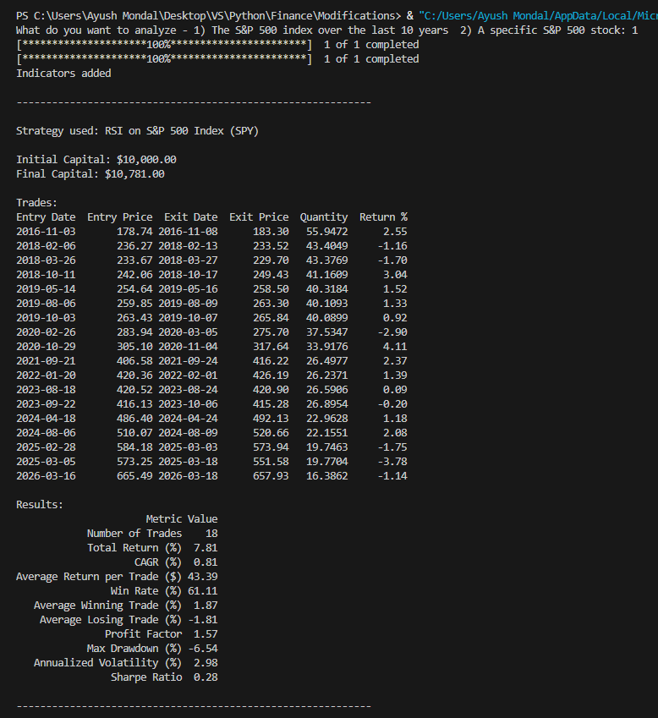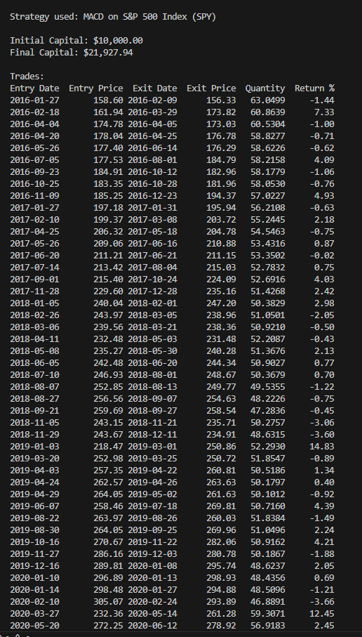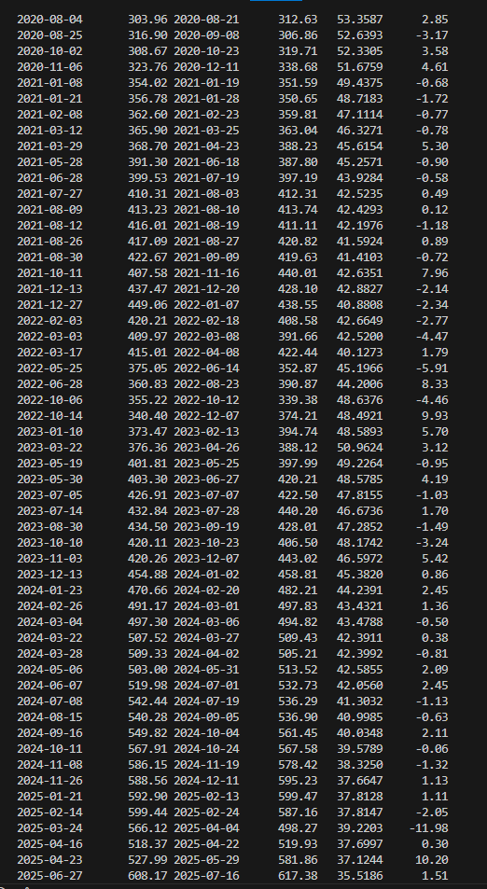
Console output -SPY: RSI strategy, trade log and results Console output -SPY: MACD strategy, trade log
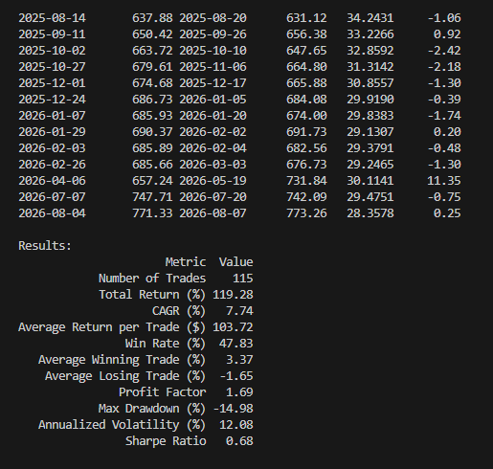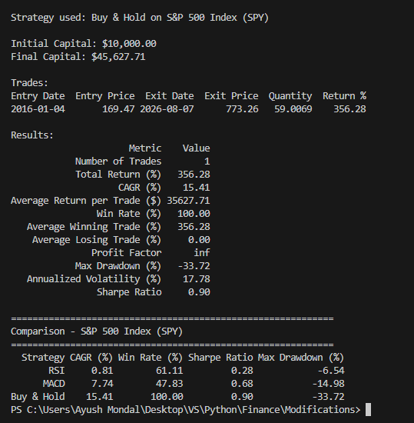
Console output -SPY: MACD strategy, trade log & result Console output -SPY: Buy & Hold results and comparison table

3.1.2 Individual Stock -Tesla (TSLA)
Table 1b. Baseline comparison -Tesla (TSLA), 2016–present.
Strategy | Total Return (%) | CAGR (%) | Sharpe Ratio | Max Drawdown (%) | Win Rate (%) | # Trades
RSI | 59.26 | 6.25 | 0.61 | -14.69 | 66.67 | 12
MACD | 5376.43 | 46.94 | 0.89 | -50.11 | 45.10 | 102
Buy & Hold | 2106.12 | 33.93 | 0.79 | -73.63 | 100.00 | 1
Observation: TSLA flips the SPY result: MACD now beats Buy-and-Hold outright on both return and risk-adjusted return, the first case in this baseline where an active strategy win (might be because of a trend) following rule has more of a sustained move to ride on a single high-momentum stock than on a diversified index, though one ticker can't confirm that accurately. RSI lags on return but wins on smoothness - best win rate, smallest drawdown of the three (a gentler ride). As with SPY, the active strategies' drawdowns are trade-chained approximations, not directly comparable to Buy-and-Hold's real equity curve (Section 2.5, assumption 12), so both are probably understated.
Console output (evidence):
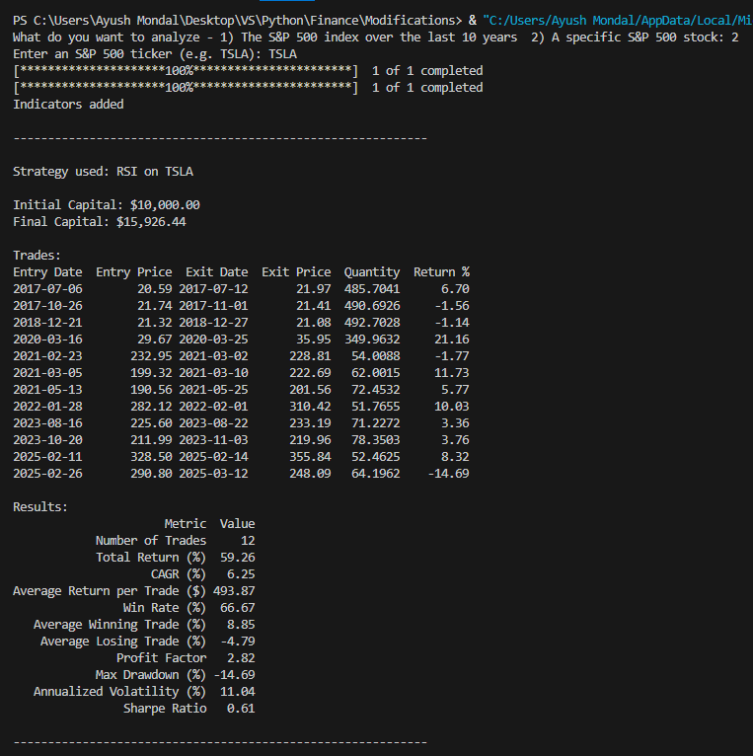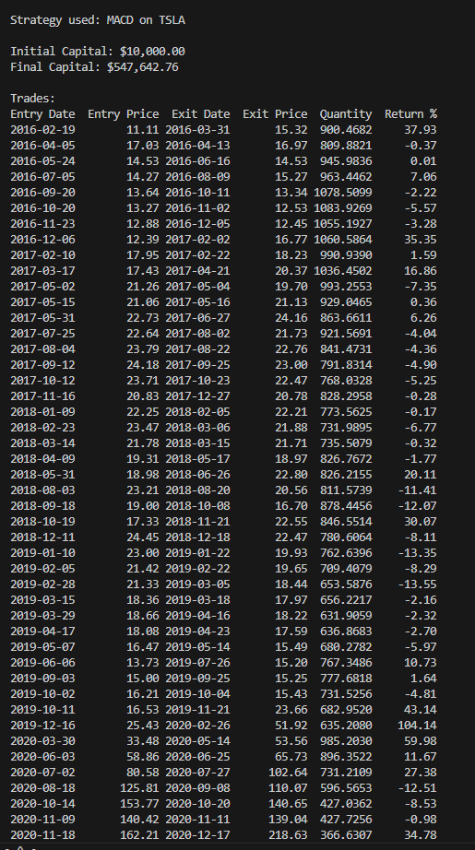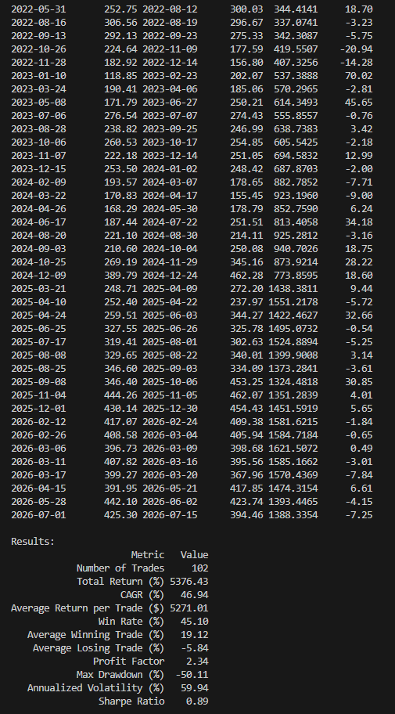
Console output -TSLA: RSI strategy, trade log and results Console output -TSLA: MACD strategy, trade log and result
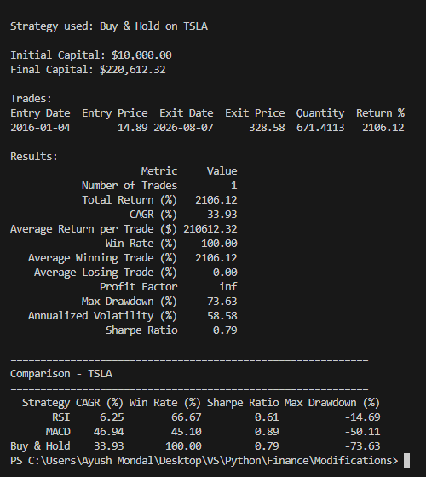
Console output -TSLA: Buy & Hold results and comparison table

3.2 Parameter Sensitivity
It tests whether the baseline result depends on the specific, largely conventional constants rather than reflecting something more fundamental about the indicators themselves. Each sweep changes exactly one constant and holds every other setting at its Table 1 baseline value.

3.2.1 RSI Smoothing Span
Table 2a. RSI performance as the EMA smoothing span varies -S&P 500 Index (SPY), baseline = 19.
Span | CAGR (%) | Sharpe Ratio | Max Drawdown (%) | Win Rate (%) | # Trades
14 (Wilder-equivalent) | 2.26 | 0.70 | -5.58 | 64.84 | 37
17 | 1.43 | 0.48 | -5.47 | 66.67 | 24
19 (baseline) | 0.81 | 0.28 | -6.54 | 61.11 | 18
21 | 1.15 | 0.46 | -2.90 | 69.23 | 13
25 | 1.29 | 0.51 | -2.90 | 70.00 | 10

Console output (evidence):

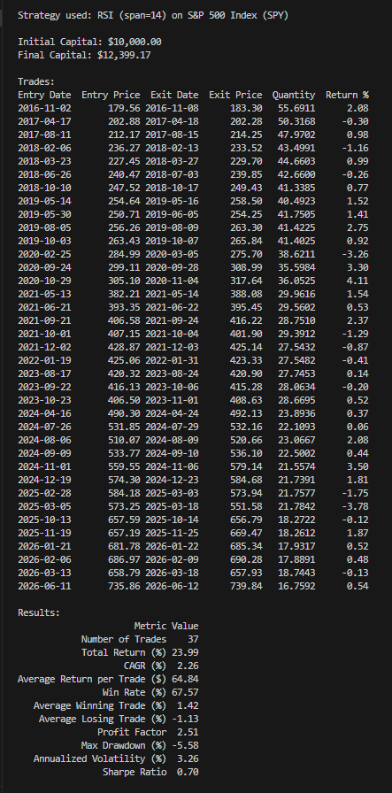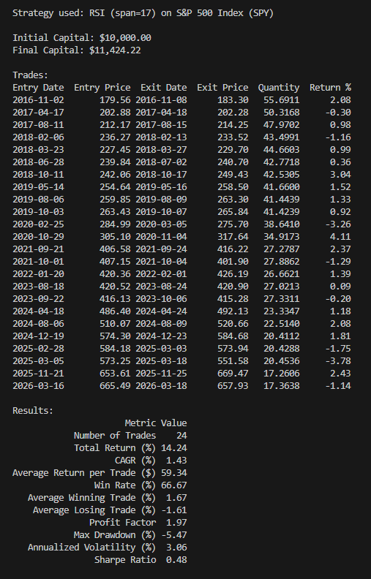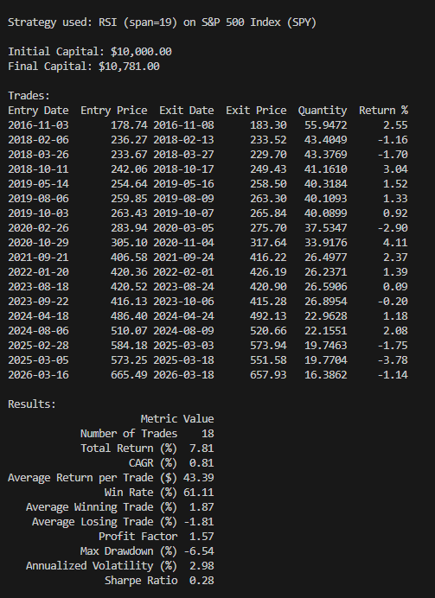
Output -SPY: RSI (span = 14) Output- SPY: RSI (span = 17) Output – SPY: RSI (span 19)

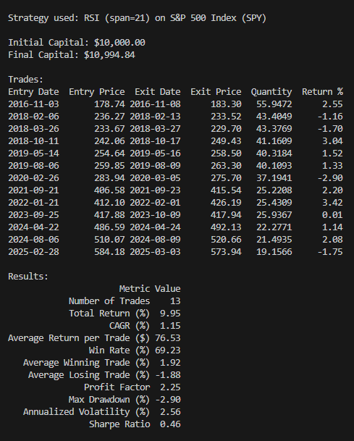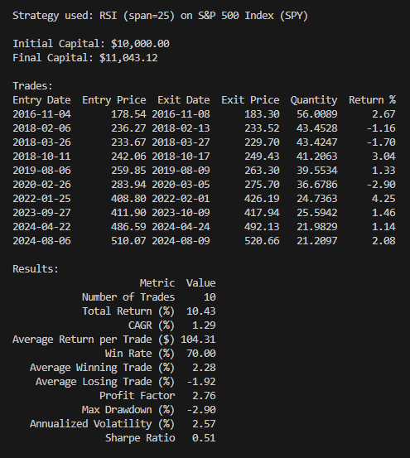
Output -SPY: RSI (span = 21) Output -SPY: RSI (span = 25)

For a cross-ticker reference point, the same spans were also run on the individual-stock baseline (TSLA); the span-19 row is the same run already reported in Table 1b, repeated here for direct comparison against the SPY sweep above:
Table 2b. RSI performance as the EMA smoothing span varies -Tesla (TSLA), baseline = 19.
Span | CAGR (%) | Sharpe Ratio | Max Drawdown (%) | Win Rate (%) | # Trades
14 (Wilder-equivalent) | 0.65 | 0.12 | -23.85 | 65.00 | 20
17 | 3.91 | 0.50 | -14.69 | 66.67 | 15
19 (baseline) | 6.25 | 0.61 | -14.69 | 66.67 | 12
21 | 6.66 | 0.61 | -14.69 | 72.73 | 11
25 | 5.50 | 0.49 | -14.69 | 75.00 | 8
Console output (evidence):
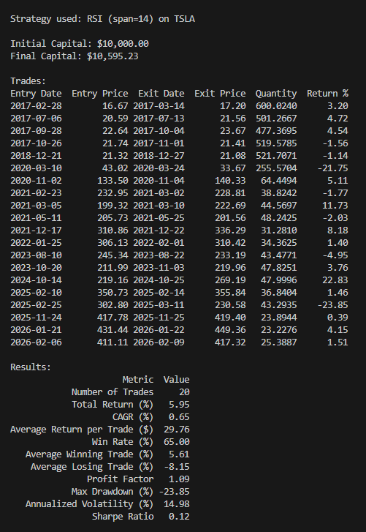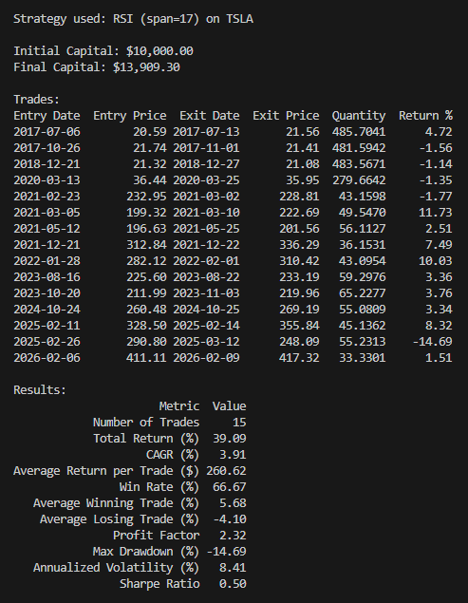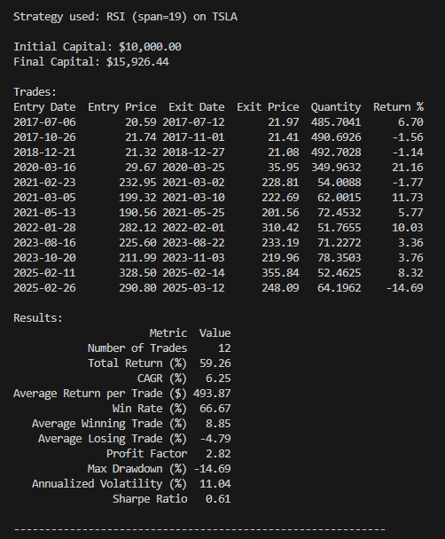
Output -TSLA: RSI (span = 14) Output -TSLA: RSI (span = 17) Output -TSLA: RSI (span = 19)
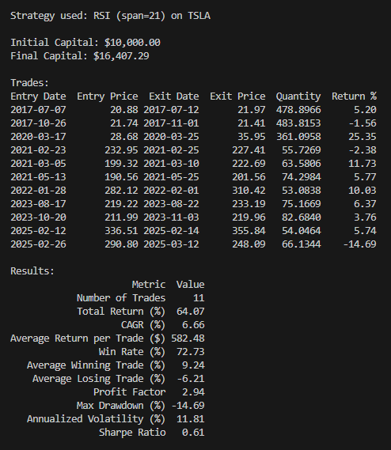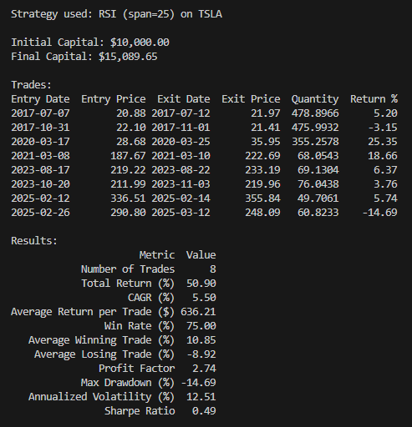
Output -TSLA: RSI (span = 21) Output -TSLA: RSI (span = 25)

Observation: The sweep is complete on both tickers, and 19 turns out not to be a local optimum on either one. On SPY, CAGR and Sharpe both dip to their lowest point at span 19 (0.81%, 0.28). On TSLA, the pattern instead peaks at 21 (6.66% CAGR) and falls off at 25, so the two tickers do not even agree on which direction more smoothing helps. What both share: win rate rises and trade count falls steadily as span increases (more smoothing means fewer, more selective entries), and Max Drawdown on TSLA is frozen at -14.69% from span 17 onward -the same single losing trade dominates regardless of span, so that number reflects one outlier trade rather than the smoothing choice.

3.2.2 RSI Entry / Exit Thresholds
Table 3a. RSI performance as the oversold-entry / recovery-exit thresholds vary -S&P 500 Index (SPY), baseline = 30 / 40.
Entry / Exit | CAGR (%) | Sharpe Ratio | Max Drawdown (%) | Win Rate (%) | # Trades
20 / 35 | 519.86 | nan | 0.00 | 100.00 | 1
25 / 40 | 0.99 | 0.41 | -2.90 | 66.67 | 9
30 / 40 (baseline) | 0.81 | 0.28 | -6.54 | 61.11 | 18
35 / 45 | 3.11 | 0.84 | -6.92 | 78.79 | 33
30 / 50 | -0.22 | -0.01 | -13.64 | 58.82 | 17
The 20/35 row's triple-digit CAGR is an annualization artifact, not a real edge: at this stricter entry threshold only a single trade fired over the full sample (a one-week hold in October 2018), and compounding a 3.04% one-week return out to a full year produces a CAGR figure with no practical meaning. Sharpe is undefined (nan) for the same reason -a single trade has no return variance to divide by. Both artifacts are themselves a finding: they expose how fragile CAGR/Sharpe become once a stricter parameter starves the strategy of trades (Section 2.5, assumption 11).
Console output (evidence):
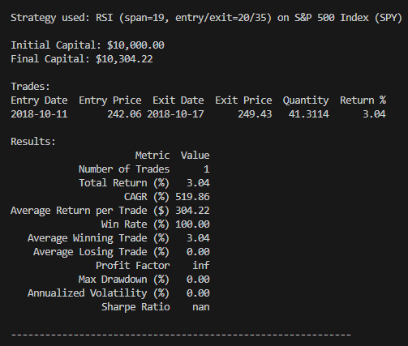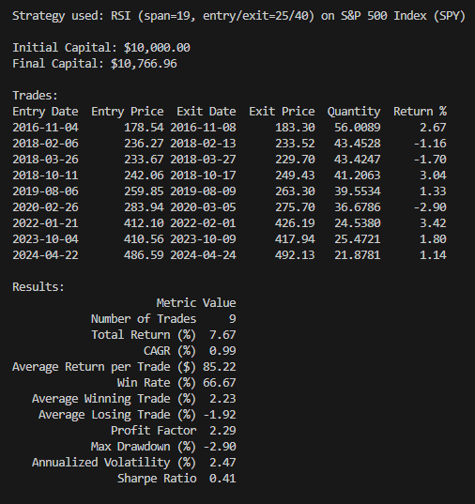
Console output -SPY: RSI (entry/exit = 20/35) Console output -SPY: RSI (entry/exit = 25/40)
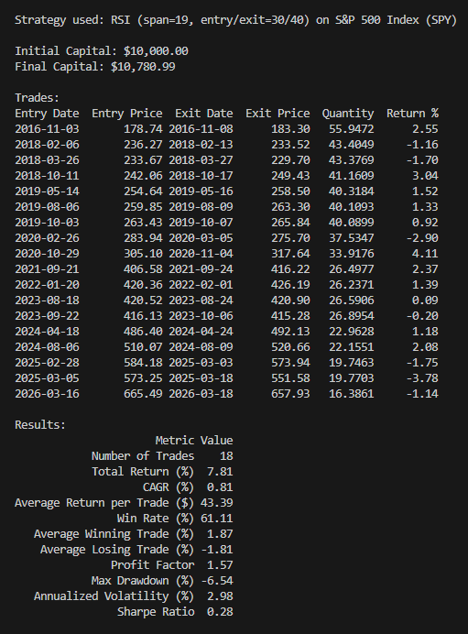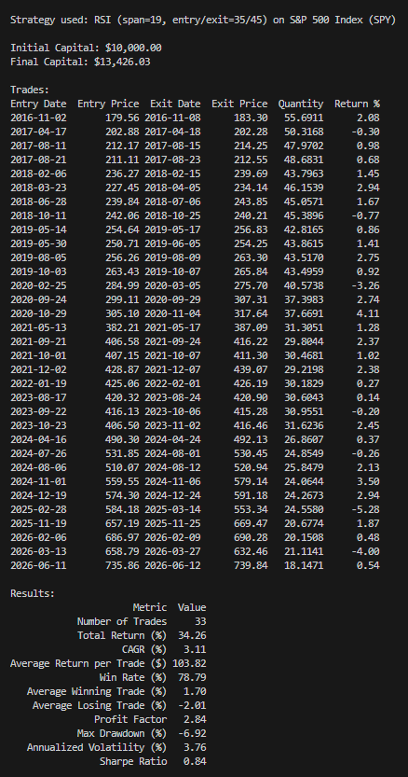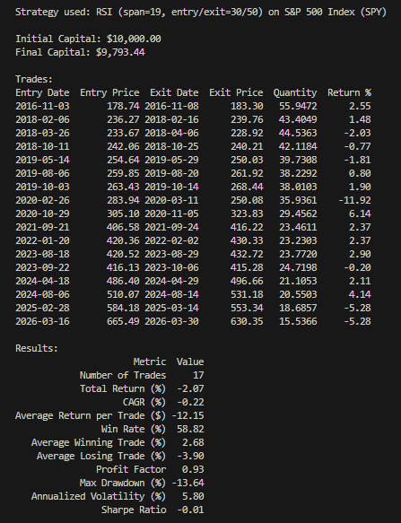
Output -SPY: RSI (entry/exit = 30/40) Output -SPY: RSI (entry/exit = 35/45 Output -SPY: RSI (entry/exit = 30/50)
Table 3b. RSI performance as the oversold-entry / recovery-exit thresholds vary -Tesla (TSLA), baseline = 30 / 40.
Entry / Exit | CAGR (%) | Sharpe Ratio | Max Drawdown (%) | Win Rate (%) | # Trades
20 / 35 | -11.37 | -0.73 | -17.85 | 50.00 | 2
25 / 40 | 2.46 | 0.26 | -14.69 | 62.50 | 8
30 / 40 (baseline) | 6.25 | 0.61 | -14.69 | 66.67 | 12
35 / 45 | -1.64 | -0.00 | -32.84 | 57.14 | 21
30 / 50 | 1.52 | 0.18 | -22.85 | 63.64 | 11
Console output (evidence):
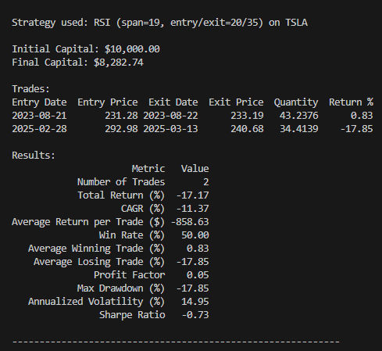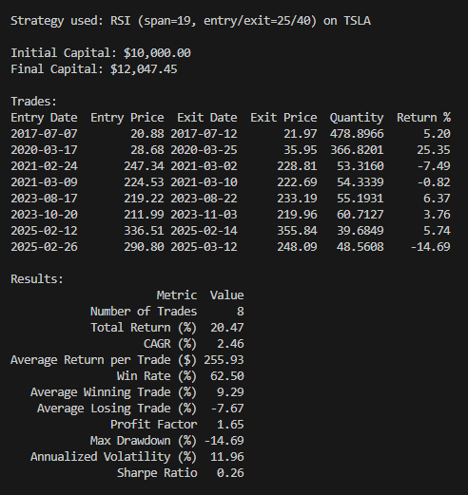
Output -TSLA: RSI (entry/exit = 20/35) Output -TSLA: RSI (entry/exit = 25/40)

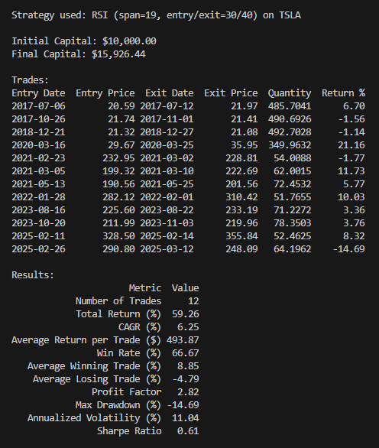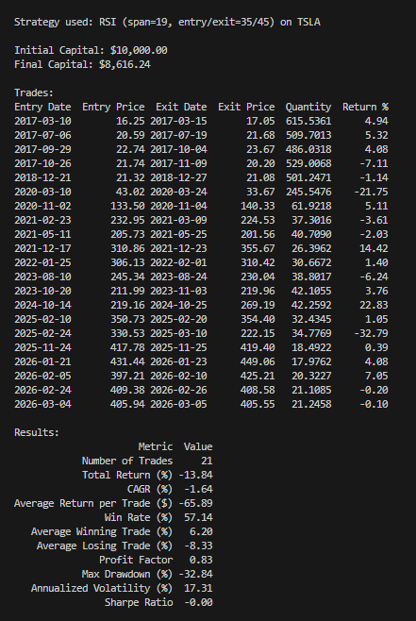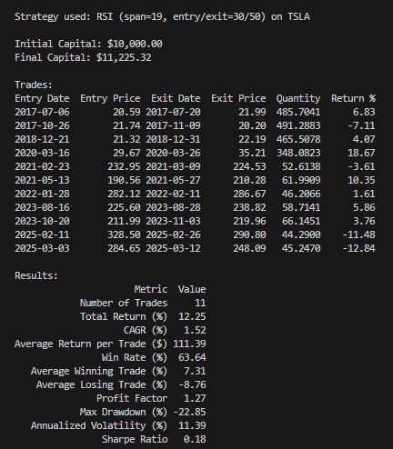
Output -TSLA: RSI (entry/exit = 30/40) Output -TSLA: RSI (entry/exit = 35/45) Output -TSLA: RSI (entry/exit = 30/50)
Observation: The win rate does rise roughly as theory predicts -SPY climbs from 58.82% (30/50) up through 78.79% (35/45) as the rules get stricter and more selective and TSLA shows the same broad direction. But CAGR and Sharpe do not track win rate cleanly and the two tickers disagree with each other more than they agree with any single story: SPY's best result in the whole sweep is 35/45 (3.11% CAGR, 0.84 Sharpe), while that exact pair is TSLA's worst (-1.64% CAGR, -32.84% Max Drawdown, its deepest of the five). TSLA's best pair, by contrast, is the 30/40 baseline. Excluding the 20/35 row's single-trade artifact, neither ticker shows a monotonic relationship between threshold looseness and performance -both move in a shape closer to a hump than a straight line, but the humps peak at different pairs. That is itself the finding: the entry/exit thresholds are not a robust, transferable setting -what helps the calmer, diversified index can hurt the more volatile single stock at the same settings, so any claimed 'optimal' threshold pair is likely specific to the instrument it was tuned on.

3.3 Temporal Robustness
This tests whether the baseline edge is stable through time or specific to one slice of the 2016–present sample (assumption 17). All three strategies use their Table 1 baseline parameters throughout.

3.3.1 Performance by Market Regime
Rather than slicing history into a handful of manually chosen calendar windows, regimes here are auto-detected directly from price data: each day is labeled by trend (Bull / Bear / Sideways) and realized volatility (High / Low), contiguous days with the same label are merged into segments, and segments shorter than 10 trading days are dropped as noise (175 of 260 raw segments on SPY were this short). This removes the subjectivity of hand-picking regime boundaries, at the cost of a 'Bear / Low Vol' bucket that never occurs in this sample -bear markets in this window were all high-volatility ones.
Table 6a. Strategy return (%) by auto-detected market regime -S&P 500 Index (SPY). Figures in parentheses are the combined number of trading days across all segments matching that regime; day counts differ slightly by strategy because each only accrues return once its own warm-up/entry conditions are met.
Regime | RSI Return % (Days) | MACD Return % (Days) | Buy & Hold Return % (Days)
Bear / High Vol | 0.0% (100d) | -17.4% (100d) | -39.5% (100d)
Bull / High Vol | 4.1% (368d) | 12.3% (381d) | 72.5% (381d)
Bull / Low Vol | 4.9% (631d) | 23.2% (659d) | 85.0% (659d)
Sideways / High Vol | -3.8% (783d) | 67.9% (799d) | 75.6% (799d)
Sideways / Low Vol | 2.7% (583d) | 10.6% (600d) | 27.8% (600d)
Table 6b. Trade count and win rate by regime -S&P 500 Index (SPY). Buy & Hold is omitted (always a single trade spanning the full sample).
Regime | RSI Trades | RSI Win Rate (%) | MACD Trades | MACD Win Rate (%)
Bear / High Vol | 0 | — | 5 | 60
Bull / High Vol | 2 | 50 | 23 | 39
Bull / Low Vol | 2 | 100 | 31 | 35
Sideways / High Vol | 10 | 50 | 29 | 62
Sideways / Low Vol | 4 | 75 | 22 | 59
Console output (evidence):
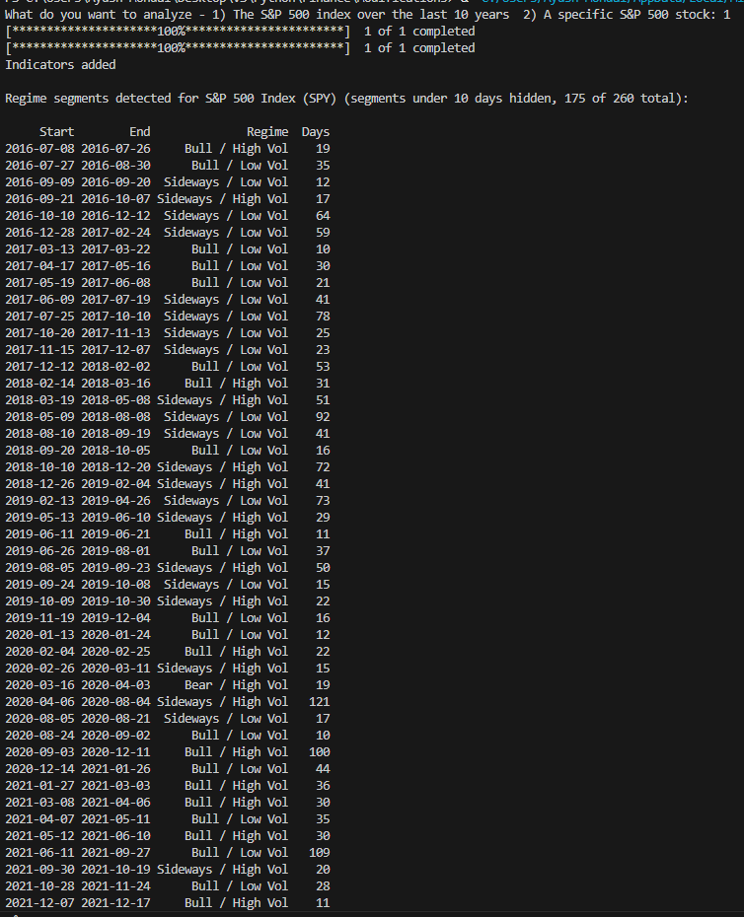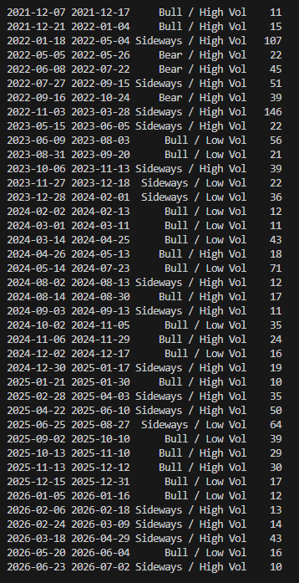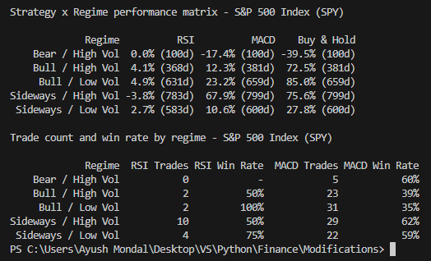
Output -SPY: auto-detected regime segments and strategy × regime performance matrix and trade count / win rate by regime

3.3.2 Rolling-Window Stability
Instead of one Sharpe ratio for the whole ~10-year sample, this recalculates it on a rolling 2-year window that steps forward every 6 months, for all three strategies on both SPY and TSLA. A strategy with a real, dependable edge should trace a roughly flat line here; one whose good headline number came from a lucky stretch should look like a rollercoaster.
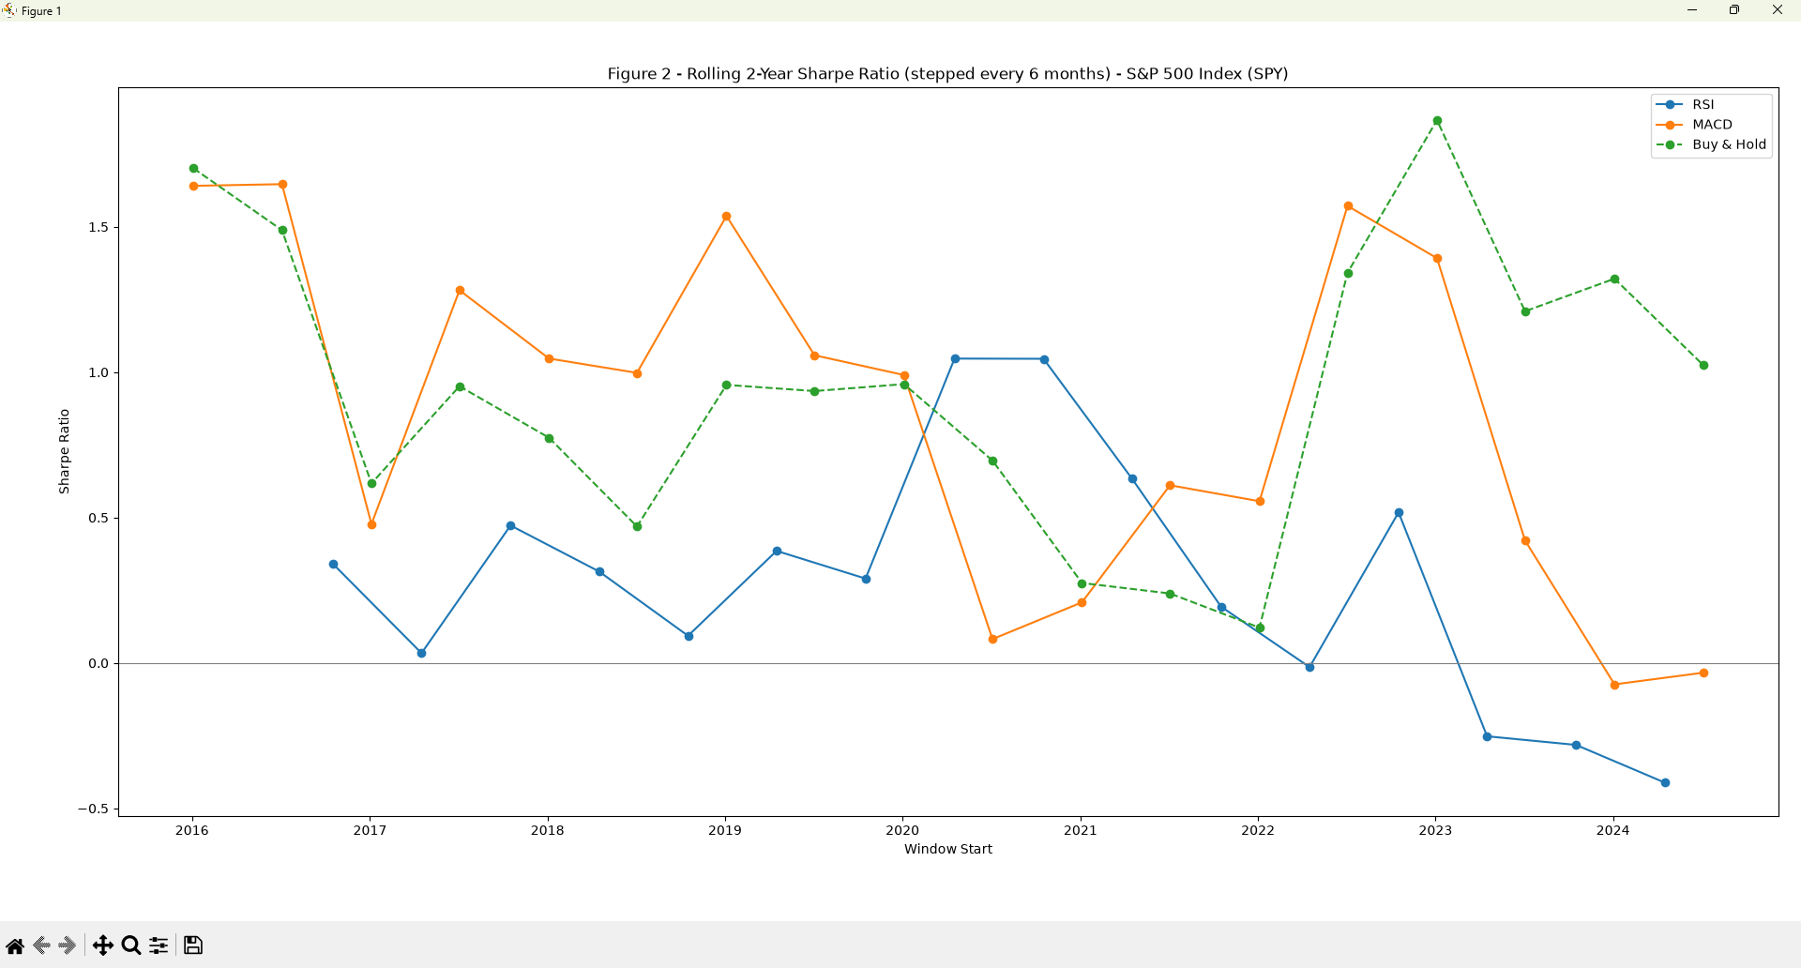
Figure 2a -Rolling 2-year Sharpe ratio, stepped every 6 months -S&P 500 Index (SPY)
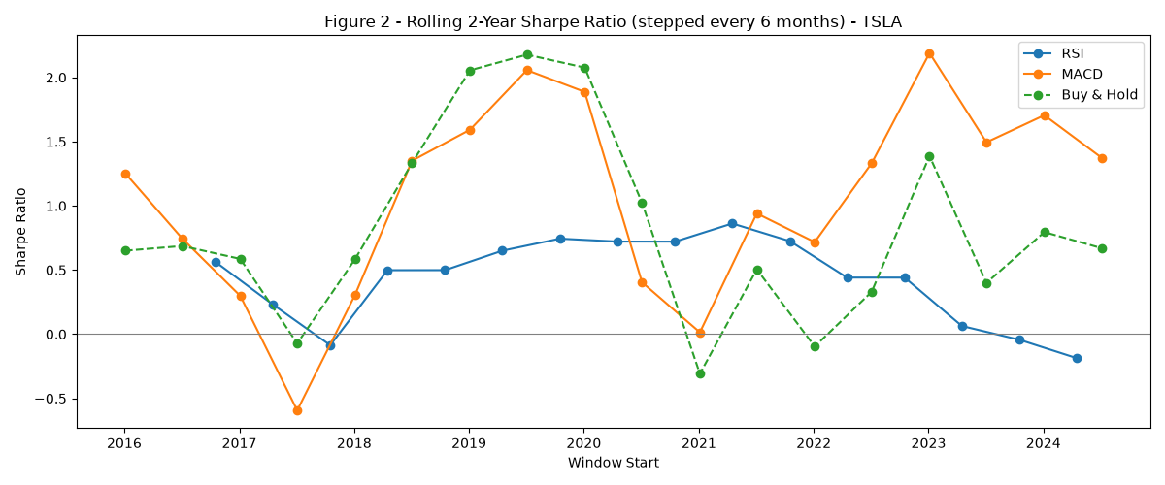
Figure 2b -Rolling 2-year Sharpe ratio, stepped every 6 months -TSLA
Observation: None of the three lines are flat on either ticker - every strategy has good stretches and bad ones. The clearest pattern is RSI: it stays the weakest of the three for most of the timeline on both SPY and TSLA, and by the most recent windows (2023–2024) it has actually dropped below zero on both - meaning in the last couple of years, RSI's risk-adjusted return went negative even while MACD and Buy & Hold were still doing fine. MACD and Buy & Hold tend to rise and fall together more closely than RSI does, both catching the same good windows (like the swings around 2019 and 2023) and the same rough patches (like around 2017 and 2021). In plain terms: whatever edge RSI showed in the full-sample numbers back in Table 1 looks like it has been fading recently rather than holding up, while MACD's edge looks more durable, moving in step with simply holding the asset rather than falling behind it.

3.3.3 In-Sample vs. Out-of-Sample Split
Parameters are frozen using only 2016–2020 data ("in-sample") and then applied, unmodified, to 2021–present data not used in that selection ("out-of-sample") - the strongest single test in this project of whether a result reflects genuine structure or in-sample curve-fitting.
This split is run on the S&P 500 index (SPY) only, not extended to individual constituent stocks such as TSLA: over a 10-year window, as several stocks have been included and excluded of the S&P 500 at different points, so no single stock's index-membership history lines up cleanly with another's and any per-stock in-sample/out-of-sample comparison would be comparing different underlying time windows in practice. The index itself does not have this problem.
Table 8. In-sample vs. out-of-sample performance -S&P 500 Index (SPY).
Strategy / Sample | CAGR (%) | Sharpe Ratio | Max Drawdown (%) | Win Rate (%)
RSI -in-sample (2016–2020) | 1.79 | 0.35 | -5.30 | 66.67
RSI -out-of-sample (2021–present) | 1.35 | 0.02 | -7.08 | 55.56
MACD -in-sample (2016–2020) | 11.87 | 1.16 | -10.07 | 52.00
MACD -out-of-sample (2021–present) | 15.06 | 0.44 | -16.47 | 44.62
Buy & Hold -in-sample (2016–2020) | 15.45 | 0.86 | -33.72 | 100.00
Buy & Hold -out-of-sample (2021–present) | 31.15 | 0.95 | -24.50 | nan
Console output (evidence):
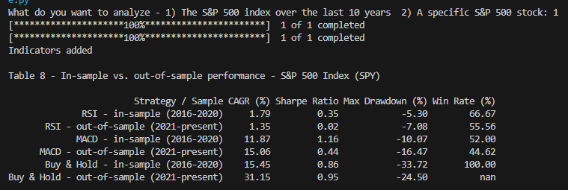
Console output -SPY: in-sample (2016–2020) vs. out-of-sample (2021–present) performance
Observation: Every strategy's raw CAGR held up or improved out-of-sample, but Sharpe tells a very different story once risk is accounted for, and the two active strategies degrade far more than the passive benchmark. RSI's Sharpe collapses from 0.35 in-sample to 0.02 out-of-sample -a roughly 94% drop that leaves it statistically indistinguishable from zero -while its win rate also slides from 66.67% to 55.56%. MACD's CAGR actually rises (11.87% to 15.06%), but that comes with a much deeper drawdown (-10.07% to -16.47%) and a lower win rate (52.00% to 44.62%), so its Sharpe still falls by about 62% (1.16 to 0.44). Buy & Hold, by contrast, is the only line in the table whose Sharpe does not fall -it rises slightly, from 0.86 to 0.95, alongside a shallower drawdown out-of-sample than in. In plain terms: whatever risk-adjusted edge RSI and MACD showed on the 2016–2020 slice they were tuned on largely does not carry over to 2021–present, while simply holding the index performs at least as well on a risk-adjusted basis in the period it was not 'selected' on -the clearest single piece of evidence in this project that the active strategies' apparent edge is partly an artifact of the sample it was measured on.

3.6 Combined-Strategy Experiments
Tests whether requiring RSI and MACD to agree, or blending them, improves on either alone -and whether the two strategies are independent enough for combination to plausibly help in the first place.
Table 11a. Combined-signal performance vs. each strategy alone -S&P 500 Index (SPY).
Rule | CAGR (%) | Sharpe Ratio | Max Drawdown (%) | Win Rate (%) | # Trades
RSI alone (baseline) | 0.81 | 0.28 | -6.54 | 61.11 | 18
MACD alone (baseline) | 7.73 | 0.68 | -14.98 | 47.83 | 115
AND -both must agree | nan | nan | nan | nan | 0
OR -either signal | 10.75 | 0.85 | -19.80 | 56.91 | 123
50/50 capital-split blend | 4.75 | 0.75 | -12.57 | 49.62 | 133
MACD trend-state replaces MA200 filter | — | — | — | — | —
Correlation between RSI's and MACD's period returns (SPY): -0.001
Console output (evidence):
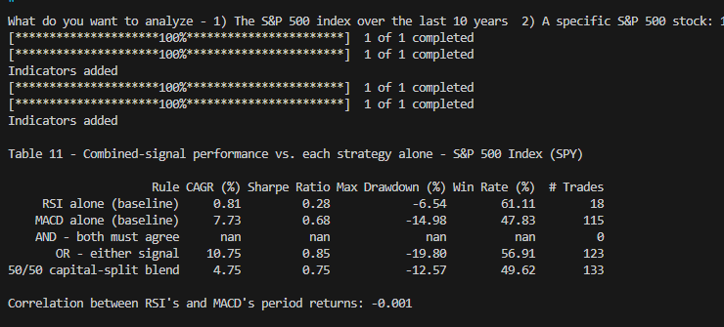
Console output -SPY: combined-signal rules vs. RSI/MACD alone
Table 11b. Combined-signal performance vs. each strategy alone -Tesla (TSLA).
Rule | CAGR (%) | Sharpe Ratio | Max Drawdown (%) | Win Rate (%) | # Trades
RSI alone (baseline) | 6.25 | 0.61 | -14.69 | 66.67 | 12
MACD alone (baseline) | 46.56 | 0.88 | -50.11 | 44.66 | 103
AND -both must agree | nan | nan | nan | nan | 0
OR -either signal | 52.44 | 1.02 | -49.28 | 50.96 | 104
50/50 capital-split blend | 37.03 | 1.09 | -41.78 | 46.96 | 115
MACD trend-state replaces MA200 filter | — | — | — | — | —
Correlation between RSI's and MACD's period returns (TSLA): -0.002
Console output (evidence):
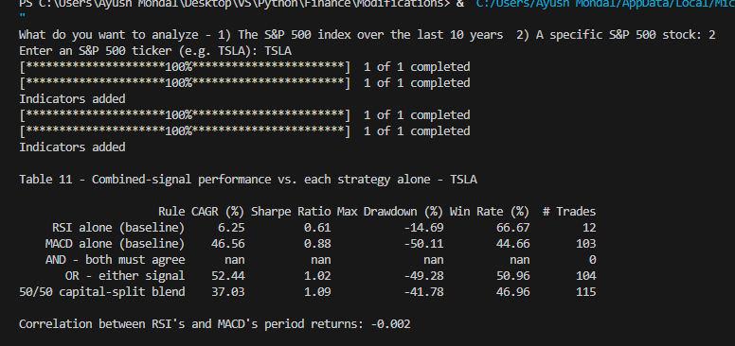
Console output -TSLA: combined-signal rules vs. RSI/MACD alone
Observation: On both tickers, RSI's and MACD's period returns are essentially uncorrelated (-0.001 on SPY, -0.002 on TSLA) - close enough to zero that the two signals rarely line up on the same trade, which shows up directly in the AND rule: requiring both to agree produces zero trades on either ticker, so its metrics are undefined (nan). The OR rule -taking either signal is the standout here, beating both individual strategies on CAGR and Sharpe on both tickers: on SPY it reaches 10.75% CAGR and 0.85 Sharpe versus RSI's 0.81%/0.28 and MACD's 7.73%/0.68, and on TSLA it reaches 52.44%/1.02 versus RSI's 6.25%/0.61 and MACD's 46.56%/0.88. The 50/50 blend is more mixed: it beats MACD's Sharpe on SPY (0.75 vs. 0.68) with a shallower drawdown and actually posts the best Sharpe of any rule on TSLA (1.09), but its CAGR trails OR by a wide margin on both tickers. So, the near-zero correlation is exactly what makes OR work as a diversification trick -I t lets the strategies cover for each other's missed opportunities rather than doubling down on the same.

3.7 Stress Tests
Tests whether the baseline edge survives the frictions and the null-hypothesis check that Section 2.5 (assumption 5) flagged as absent from the idealized back test.

3.7.1 Transaction Cost Sensitivity
Table 12. CAGR and Sharpe under increasing per-round-trip transaction cost.
Cost per Round Trip | RSI CAGR (%) | RSI Sharpe | MACD CAGR (%) | MACD Sharpe
0.00% (baseline) | 0.81 | 0.28 | 7.74 | 0.68
0.05% | 0.71 | 0.25 | 7.15 | 0.63
0.10% | 0.61 | 0.22 | 6.57 | 0.59
Console output (evidence) -0.05% per round trip, S&P 500 (SPY):
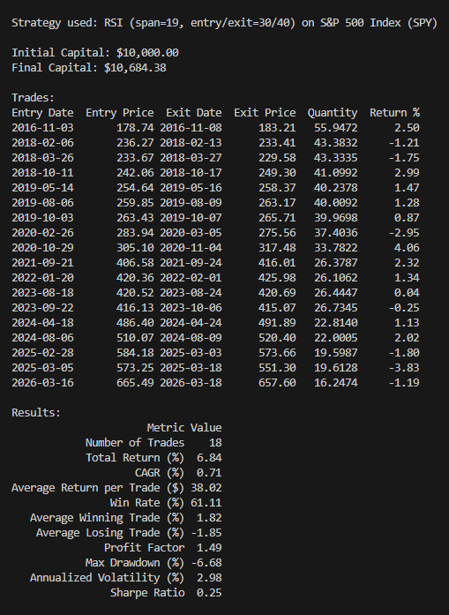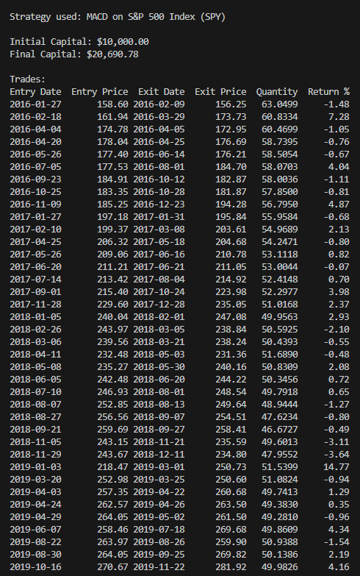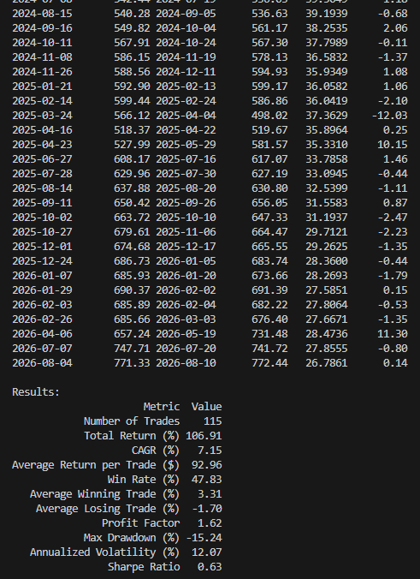
Output -SPY: RSI (span=19, entry/exit=30/40) Output -SPY: MACD
Console output (evidence) -0.10% per round trip, S&P 500 (SPY):
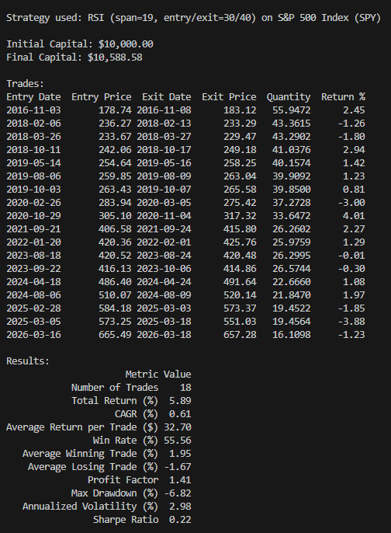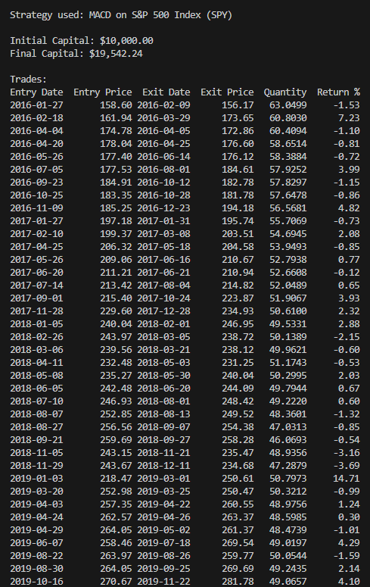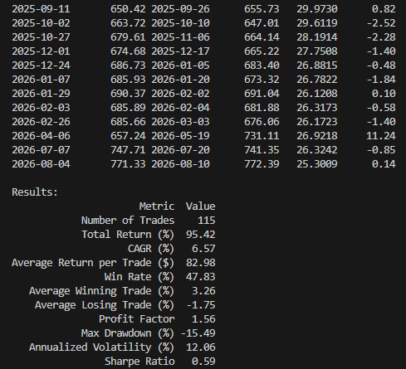
Output -SPY: RSI (span=19, entry/exit=30/40) Output -SPY: MACD

So.. does RSI and MACD actually work?
These strategies got me curious to deep dive into. A lot of people on the internet claim "buy when RSI hits 30, sell when it hits 70" or "the MACD crossed over, time to buy" – as if it's some secret formula that actually works. Nobody ever really proves it though. Instead of downloading trading bots from Github, I did it this way or else I'd have no idea why it gave me the specific output. Building it myself means I can avoid fabrication and witness the strategies actually working out.
But this is not the end. There’s scope to test different holding-period limits for RSI, test other MACD speed settings, run more stocks across different sectors, test international markets (not just the US), run a "fake random signals" sanity check to make sure the results aren't just noise, and do an actual statistical significance test.
Does it hold up over time, or did it just get lucky once?
Next I checked whether these strategies' performance depends on when you tested them. I built (well, ran my own version of) a rolling 2-year Sharpe ratio check -basically instead of one big performance number for the whole 10 years, you get a performance number for every 2-year chunk, sliding forward every 6 months.
Turns out RSI's performance has actually been sliding downward and even went negative in the most recent couple years, while MACD and buy-and-hold were still doing fine in that same stretch. So whatever "edge" RSI had earlier in the sample looks like it's fading, not something solid you could count on going forward.
The most honest test: fixed rules, evaluated on data they never touched
This is honestly the test that mattered most. RSI’s and MACD’s settings were never fitted to this data in the first place – just fixed, conventional constants (RSI span 19, entry/exit 30/40; MACD 12/26/9) – so there was no actual "training" step to freeze. What I could still test was whether those same fixed settings performed consistently when evaluated separately on 2016–2020 versus 2021–present, instead of just looking at one combined 10-year number. This is basically how you catch a strategy whose good look was really just one lucky stretch of the sample dominating the average -a real risk in this kind of research even without any explicit parameter-fitting.
And yeah -RSI basically fell apart. Its risk-adjusted performance (Sharpe ratio) dropped from 0.35 down to 0.02, which is close enough to zero that it might as well be doing nothing. MACD also dropped a lot, even though its raw returns went up (turns out it just got way riskier, not better). Buy-and-hold, meanwhile, didn't drop at all -its Sharpe ratio actually went up slightly. So the "boring" strategy of doing nothing held up better than the "smart" ones once tested honestly. That's kind of the whole thesis of this project in one experiment.
Then I made it realistic (fees hurt)
Backtests usually pretend trading is free, which it's not. So I added a simplified round-trip transaction-cost model – a flat 0.05% and 0.10% shaved off each trade's exit price, standing in for commission and slippage combined. It's not a full simulation of real execution (a real broker's costs vary by trade size, liquidity, and order type), but it's enough to show direction. Even that small, simplified fee noticeably chipped away at both strategies' already-thin returns, especially RSI since its returns were small to begin with. Doesn't take much friction to eat an edge that wasn't huge in the first place.
What if I combine RSI and MACD?
This part was actually a fun surprise. I checked how correlated RSI's and MACD's returns were with each other, and it turned out to be basically zero -like -0.001, nothing. Which means they're not really reacting to the same stuff.
Because of that, requiring BOTH signals to agree before trading (an "AND" rule) barely ever happened -like zero trades on both tickers, since two nearly-unrelated signals almost never line up. But taking EITHER signal (an "OR" rule) actually beat both individual strategies on both return and risk-adjusted return, on both SPY and Tesla. Kind of like a mini diversification hack -letting each strategy catch opportunities the other one misses, instead of overlapping.
What I still haven't finished
So... what's the actual takeaway?
Nothing here says RSI or MACD are magic. If anything, the honest tests (especially training vs. testing on unseen data) make it look like a lot of their apparent success just doesn't survive real scrutiny -RSI in particular. MACD held up a little better, especially on a single trending stock like Tesla, and combining signals with an OR rule showed some real promise. But "just buy and hold" kept being annoyingly hard to beat once everything was tested fairly.
Which honestly might be the most useful thing I learned from this whole project: a strategy looking good on a backtest means almost nothing until you've tried to break it.

